## Proforma Receipt

Receipt No: ORBIT/2025/1/{{receipt_no}} Date: {{date}}

**Received from:**

Customer Name: {{customer_name}}

Address: {{address_line1}}

Phone Number: {{phone}}

Email (if available): {{email}}

**Payment Details:**

Amount Received: ₹ {{amount_received}}/-

Payment Mode: {{payment_mode}}

Reference ID (if available): {{reference_id}}

Date of Payment: {{payment_date}}

**Towards:**

Full Payment for Orbit PT Pro Electric Power Tiller

Balance amount of Rs. 0/- to be paid before delivery.

Delivery date: {{delivery_date}}

**Acknowledgement:**

We acknowledge receipt of the above-mentioned amount as the final installment towards booking of the Orbit PT Pro Electric Power Tiller. This receipt confirms the reservation of your machine. The final invoice will be issued 1 week after full payment and delivery.

**Authorised Signatory**

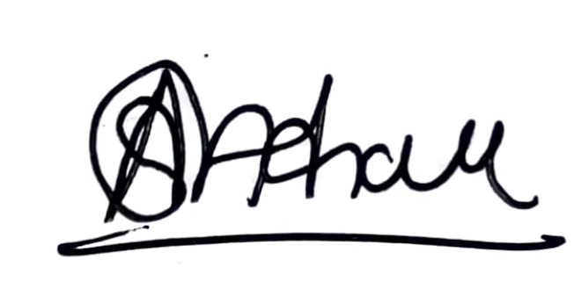

For Higher Orbit Agritech Pvt. Ltd.

GST: 27AAHCH1976Q1ZS

## Annexure

|  |  |
| --- | --- |
| Item Name | Quantity |
| 12 HP PT Pro | {{quantity_pt_pro}} |
| Battery Sets | {{quantity_battery}} |
| Fast Chargers | {{quantity_charger}} |
| 1 Set of Sugarcane Blades(Weeding) | {{quantity_blade_weeding}} |
| 1 Set of Sugarcane Blades(Earthing-up) | {{quantity_blade_earthing}} |
| 1 Set of Tyres (5x10) | {{quantity_tyres}} |
| Toolkit | {{quantity_toolkit}} |
| Ginger Kit | {{quantity_ginger}} |
| Seat | {{quantity_seat}} |
| Jack | {{quantity_jack}} |
| BuyBack Guarantee | {{quantity_buyback_guarantee}} |
| Front Dead Weight | {{quantity_front_dead_weight}} |
| Wheel Dead Weight | {{quantity_wheel_dead_weight}} |